TEMPORAL VARIATIONS IN SUBLIMATION AND THEIR RELATION WITH RIDGE FORMATION IN MARTIAN MID-LATITUDE ICE SCARPS. L. S. Perez-Mancipe¹, A. M. Bramson², K. L. Laferriere³, D. M. H. Baker⁴, ¹Universidad de los Andes, Bogotá, Colombia (ls.perez2@uniandes.edu.co), ²Purdue University, West Lafayette, IN, ³University of Central Florida - Florida Space Institute, Orlando, FL, ⁴NASA Goddard Space Flight Center, Greenbelt, MD.

Introduction: The mid-latitude regions of Mars have abundant evidence for the presence of water in the form of shallowly buried ice deposits. These ice sheets undergo both accumulation and sublimation, two factors which vary over time in response to changes in Mars’ orbital parameters (orbital forcing). Ice-exposing scarps are found in the northern and southern midlatitudes, revealing the internal structure of thick (~100 m), massive ice deposits which may be part of the latitude-dependent mantle [1].
These scarp sites are characterized by a steep (~45º) pole-facing scarp, and a pit with roughly triangular appearance [2] as shown in Figure 1. These scarps are hypothesized to form due to sublimation initiating at a localized point, after which the scarp retreats equatorward, resulting in a face that is nearly perpendicular to the direction of retreat. Ridge structures within the pit are observed parallel to the present-day scarp, hypothesized to represent periods of slower sublimation, while intervening depressions or "valleys" correspond to episodes of rapid ice loss [3].
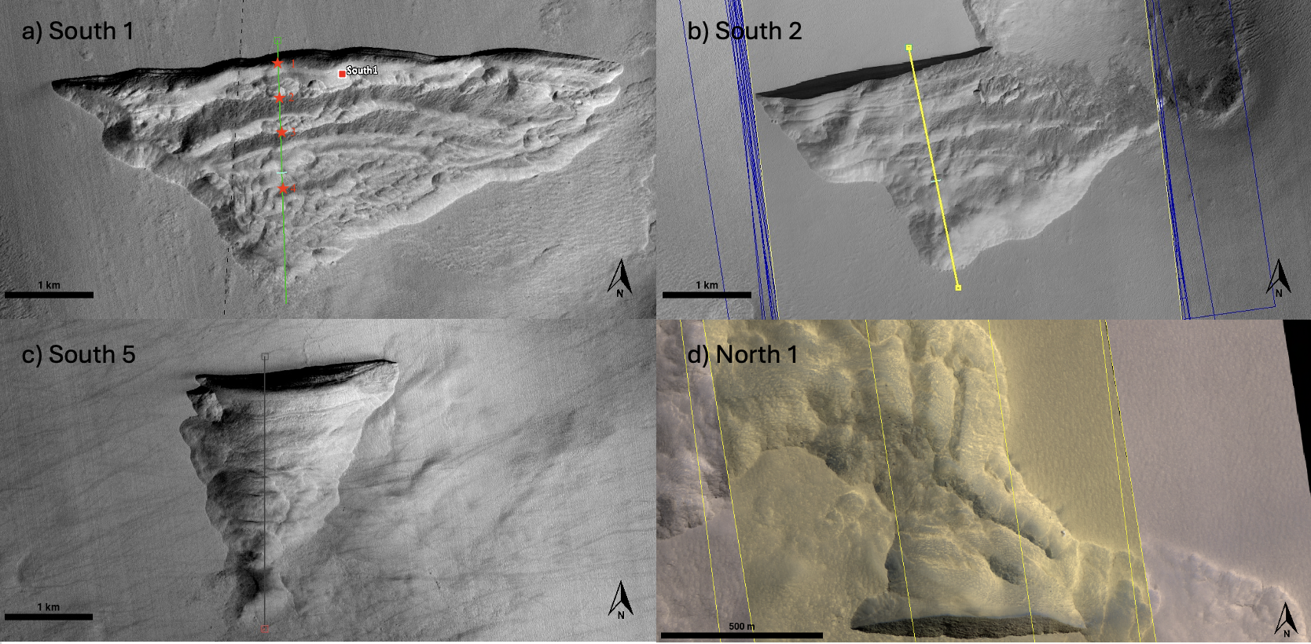
Figure 1: HIRISE images of three icy scarps found in the southern hemisphere and one in the norther hemisphere [d]. South 1: upper left, -56.6°N 114°E. South 2; upper right, -55.1°N 109.4°E. South 3: lower left, -58.3°N 93.7°E. South 5: lower right, -57.2°N 89.8°E.
We aim to test this hypothesis to understand how orbital forcing affects the geomorphology of these icy scarp sites and investigate if variable retreat rates is a plausible explanation for the observed ridges. To address this, we aim to characterize and compare ridge morphologies—such as number and spacing—across scarps in both hemispheres; and quantify the relationship between obliquity-driven sublimation cycles and ridge formation.
Mapping: Using the catalog of exposed ice sites [5], we mapped the scarp sites based on the number of ridges and the spacing between them using the software JMARS to trace elevation profiles perpendicular to the scarp face, allowing us to identify the number of topographic ridges and measure the average spacing between them. Each scarp was cataloged with its coordinates, ridge count, mean ridge separation, and brief notes on its visual appearance. In cases where DTMs were not available, we relied on HiRISE imagery to visually count the number of ridges and separation. While less precise, this approach still provided a general sense of ridge frequency and clarity.
All collected data were compiled into a table to enable comparison across hemispheres. Particular attention was given to potential morphological differences between Northern and Southern hemisphere scarps, with an emphasis on the clarity and frequency of ridge expression.
Thermal model: We used a 1D semi-implicit thermal conduction model that simulates the energy balance at the Martian surface and the heat transfer between numerical subsurface layers [4]. The model then calculates stability of the H₂O ice via free and forced convection for exposed ice and diffusive vapor exchange through a surficial lag deposit for subsurface ice. The model was applied to three mid-latitude scarps (South 1, 2 and 5) using present-day topography and extended over the last 20 Mya by incorporating time-varying orbital and axial parameters. Thus, the inputs varied according to the latitude, slope and orientation of each icy scarp. Cumulative horizontal retreat is used to quantify ice loss, and temporal transitions in sublimation regimes are identified through inflection points in its derivative.
While we initially modeled the retreat of the scarps over 20 Mya, we found that the total sublimation exceeds the observed length of the scarps after just ~0.5 Mya. We thus focus our analysis on this temporal extent. With the topographic profiles of each scarp (taken from HiRISE DTMs), we qualitatively associated the ridges to the periods of slow sublimation.
Results and Discussion: We found that scarps in the southern hemisphere tend to exhibit more ridges than those in the north, with average counts ranging from 3 to 5 in the south, compared to 2 to 3 in the north. Ridges in the south also appear more clearly defined and tend to run parallel to the scarp face, as seen in panel d) of Figure 1 in comparison to the other panels. In contrast, northern scarps frequently display diffuse ridge patterns, and in some cases—such as North 1 (shown in Figure 1 d)), North 3, and North 8—ridges appear perpendicular to the scarp. This suggests that their origin may differ and may not be solely attributed to scarp retreat.
Regarding the sublimation rates, based on the length of the pits (from initiation point to present-day scarp), which is approximately 2.5 – 3 km, we find that these features have only been retreating for the past 0.5 Mya. This age is younger than the 2.4 Mya age suggested by previous studies [2] that assume a constant retreat rate over time. Additionally, this suggests that the variations in eccentricity and longitude of perihelion have a more dominant effect on the stability of these features than the variation in obliquity, and may lead to the formation of the ridges found in the scarp sites. All three scarp sites (South 1, 2 and 5) are found to exhibit similar behavior, with scarp initiation ages ~0.5 Mya.
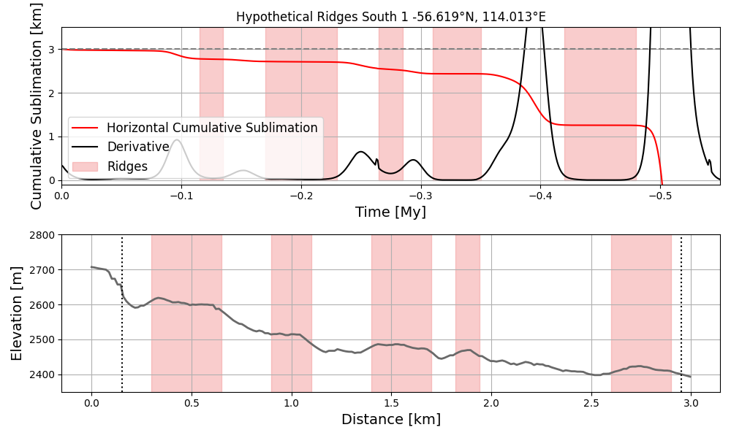
Figure 2: South 1 comparison between the horizontal cumulative sublimation plot (upper plot) along the extension of the scarp site that shows its derivative and its inflection points highlighted, with the topographic profile (lower plot) with the visible ridges highlighted.
Figures 2, 3 and 4 show the horizontal cumulative sublimation plots over the past half million years with the periods of low sublimation highlighted in red and their topographic profiles shown in the panels below, with the locations of ridges highlighted. The inflection points in the cumulative sublimation correspond to periods of low sublimation. We hypothesize that at these times the scarp would stabilize in place and develop ridges at the base of the cliff. From our mapping, we observed that scarps 1 and 2 have 5 ridges, which aligns with the number of inflection points from the sublimation model, supporting this hypothesis. If our interpretation of ridges corresponding to periods of low sublimation is correct, our results therefore could allow us to place ages on the individual ridges. However, we note that some ridges in the other scarp sites are more diffuse and some of them are not consistent horizontally along the site, which may be related to additional processes not considered by our sublimation-based model. This could include heterogeneities within the ice deposit which could cause differential retreat rates that would not be purely driven by orbital forcing-induced climate changes.

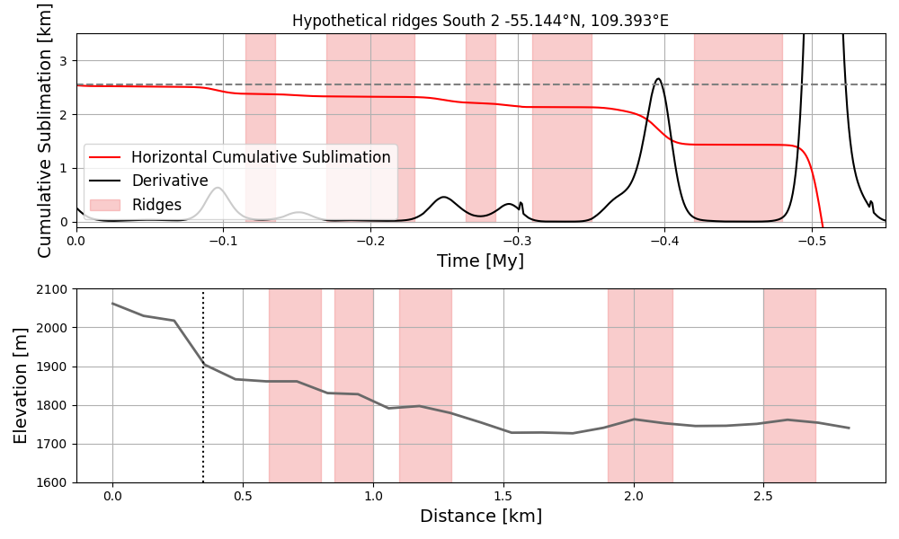
Figure 3: South 2 comparison between the horizontal cumulative sublimation plot (upper plot) along the extension of the scarp site that shows its derivative and its inflection points highlighted, with the topographic profile (lower plot) with the visible ridges highlighted).

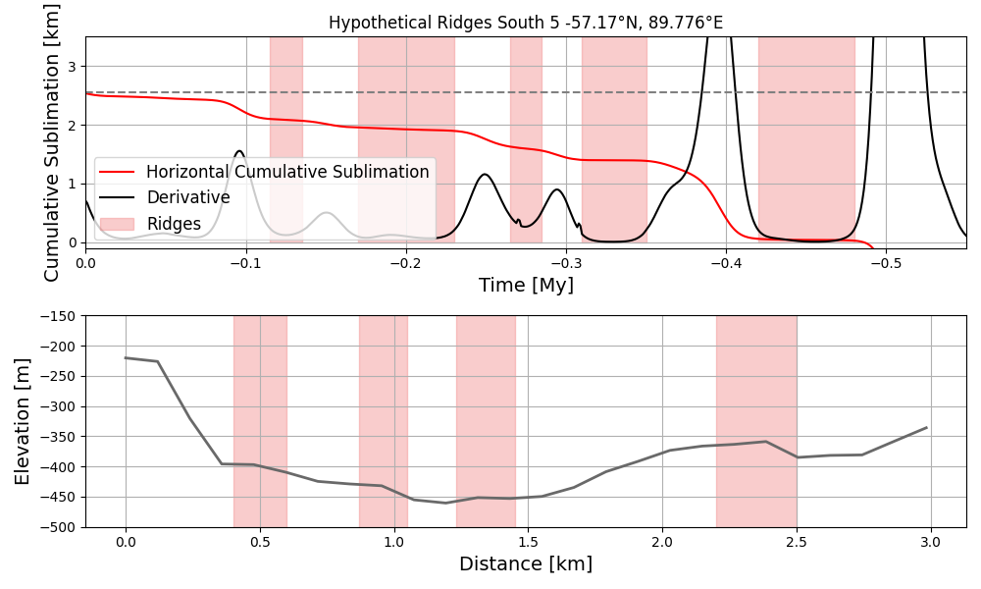
Figure 4: South 5 comparison between the horizontal cumulative sublimation plot (upper plot) along the extension of the scarp site that shows its derivative and its inflection points highlighted, with the topographic profile (lower plot) with the visible ridges highlighted.

References: [1] Dundas, C. M. et al. (2018). Science, 359(6372):199–201. [2] Williams, K. et al. (2022). Icarus, 386:115174. [3] Head, J. W. et al. (2003). Nature, 426(6968):797–802. [4] Bramson, A. M. et al. (2017). Journal of Geophysical Research: Planets, 122(11), 2250-2266. [5] Dundas, C. M. et al. (2021). Journal of Geophysical Research: Planets, 126(3):e2020JE006617.

